Make Your Own Dragon
To make them, you will need:
- Pipe cleaners – You’ll need 4 of
one color and 1 contrasting color
for each dragon.
- Craft foam
- Googly eyes
- Hot glue gun or Elmer’s Glue
- Scissors

Instructions:
- First cut the yellow pipe cleaner in half, then fold one of the pieces in half again.
- Using a pen as guide, wrap a green pipe cleaner around the yellow one as shown in the pictures. Leave a little of the folded end of the yellow pipe cleaner poking out as a nose. Wrap all but the last half inch around the folded yellow pipe cleaner. The yellow pieces can then be shaped as horns.
- Insert the end of a second green pipe cleaner into the back of the head, and twist together with the end of the head pipe cleaner.
- Using the pen method again wind the pipe cleaner around to make the body.

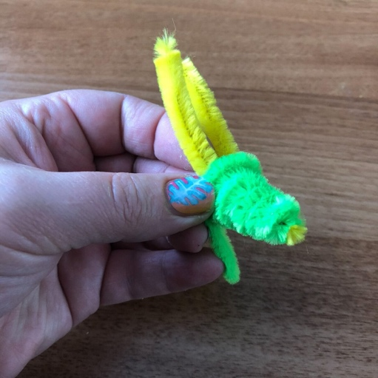
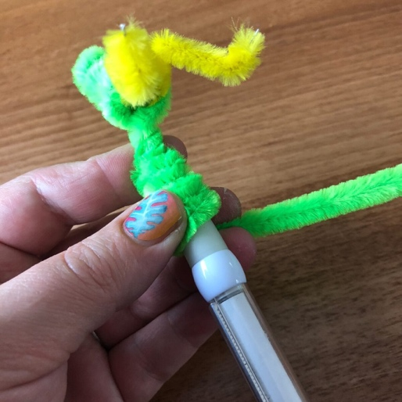

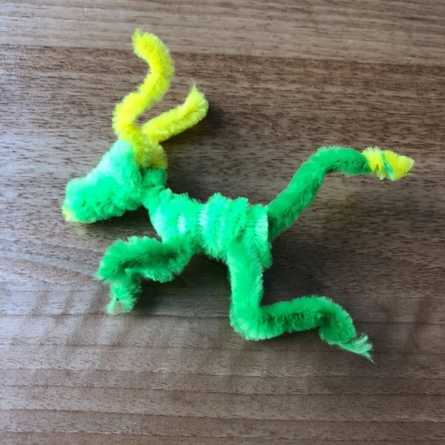
- Cut another green pipe cleaner in half then one piece in half again. Use a quarter of the pipe cleaner to make the front legs, and the half piece to make the back legs. Simply fold the pieces in half and push through the body coil. Shape the legs as shown in the pictures.
- To make the tail wrap a small amount of yellow pipe cleaner around the end of the last quarter piece of green pipe cleaner. Then insert the other end into the back of the body with some glue on the end to keep it secure.
- Then use the glue to stick some googley eyes onto the head.
- To make the wings, fold the last green pipe cleaner as shown, and cut off the last 2 sections. Glue these to a piece of foam sheet. If you don’t have foam then a sheet of stiff card will do.
- When completely dry, cut out your wings and glue them onto the body, pushing the ends between the pipe cleaner coils.
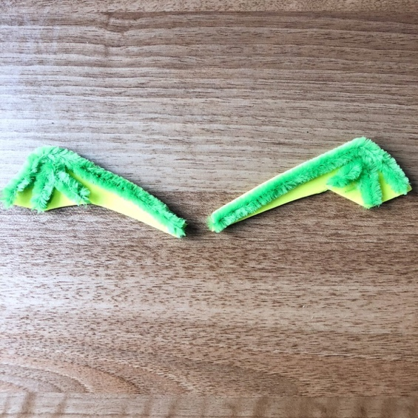
- When completely dry he (or she) is ready to be played with. The good thing about using pipe cleaners in the wings is that they can be carefully positioned. You can obviously make your dragon using all sorts of different color variation, and I love the fact that although I’ve used the same method, no two dragons that I’ve made are the same.

*Craft from https://blissfuldomestication.com/pipe-cleaner-dragon/

